Student name:
Philosophy & Religion
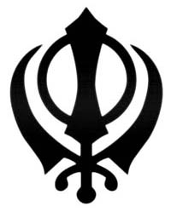
Match the symbols with the name of the religion:
Buddhism
Hinduism
Islam
Sikhism
Judaism
Christianity
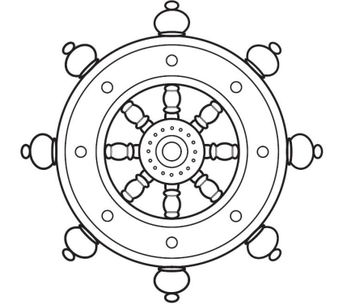
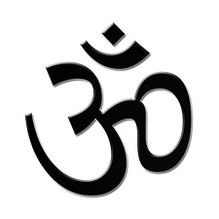
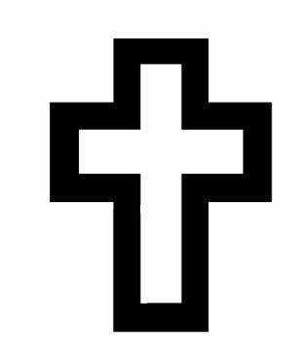
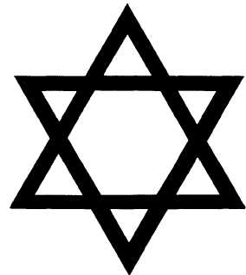
Hint: searching for “symbol+Islam” or “symbol+Sikhism” on Google Images will show you some answers!
Ultimate Questions
Ultimate questions are ones that are:
- About important issues
- Difficult to answer
- Encourage debate
For example:
“Where did the universe come from?” is an ultimate question.
“Do you like the taste of apples?” is not an ultimate question.
Other examples of ultimate questions: “What is the soul?”, “does God exist?”, “what is the difference between right and wrong?”
Make a list of ultimate questions that you are curious about
(extension on the next page):
___________________________________________________________
___________________________________________________________
___________________________________________________________
___________________________________________________________
___________________________________________________________
___________________________________________________________
___________________________________________________________
___________________________________________________________
Ultimate Questions: Extension
Choose any one of your questions; try your best to answer it!
___________________________________________________________
___________________________________________________________
___________________________________________________________
___________________________________________________________
___________________________________________________________
___________________________________________________________
___________________________________________________________
___________________________________________________________
___________________________________________________________
___________________________________________________________
___________________________________________________________
___________________________________________________________
___________________________________________________________
___________________________________________________________
What do Buddhists believe?
Make a mind-map (spider-diagram) showing Buddhist beliefs.
If you’re stuck, use the internet or a book from the library to find the answers!
BRONZE = 6 beliefs Silver = 9 beliefs Gold = 12 beliefs
Students who achieve gold will be given a sticker!
e.g. “It is possible to end all suffering”

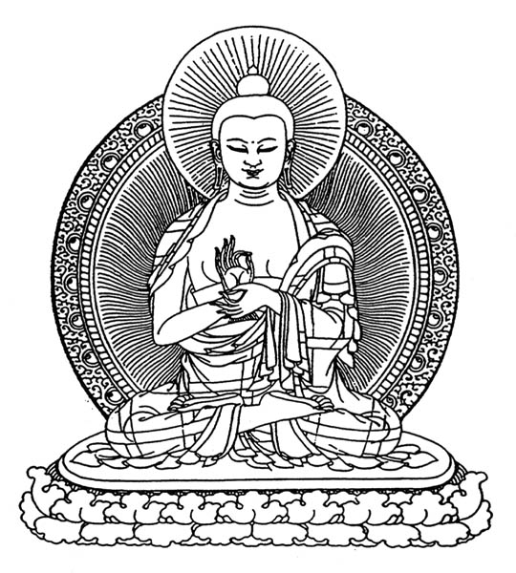
Why do Buddhists Meditate?
Bronze = 4
Silver = 8
Gold = 12 (sticker)
Why do Buddhists meditate?
What are the benefits of meditation?
Make a list of ideas:
______________________________________________
______________________________________________
______________________________________________
______________________________________________
______________________________________________
______________________________________________
______________________________________________
______________________________________________
______________________________________________
______________________________________________
______________________________________________
Match the following key words to their meaning:
The founder of Buddhism, his name means ‘awakened one’
A way of calming the mind, Buddhists do this in order to reach enlightenment and end suffering.
A Buddhist word for suffering.
Meaning ‘awakening’, this is the ultimate goal of Buddhism
A Buddhist word for action, whether it is good or bad will affect the amount of suffering experienced in life.
The view that after we die, we will be reborn in a new body.
A type of flower, often used as a symbol of the path of enlightenment in Buddhism.
Dukkha
Karma
Lotus
Buddha
Meditation
Enlightenment
Reincarnation

Using Capital Letters in Philosophy & Religion
Capital letters should be used:
- When writing “I” (e.g. “I think philosophy is interesting”)
- At the start of sentences
- For names (e.g. Adam, God, Buddha)
- For places (e.g. England, Europe, Heaven, Hell, The World, The Universe)
- For the names of religions (e.g. Buddhism, Christianity, Islam)
- For the names of religious groups (e.g. Buddhists, Christians, Muslims)
- For the names of books: The Bible, ‘The Tempest’ (Shakespeare), or The Koran
- For days of the week, holidays and months: Wednesday, Christmas, June, July
Circle all the missing capitals in the following passage.
Count up the errors and write that number in the box!
Whoever spots the most mistakes gets a sticker!

“most buddhists do not believe in god, which is one of the ways that buddhism is different to christianity. one of the reasons christians believe in god is because his existence is taught in their holy book: the bible.
the bible also teaches that when people die they will either be rewarded by going to heaven (a place of eternal reward), or they will go to hell (a place of eternal punishment). buddhists, however, tend not to believe in heaven or hell: many buddhists believe in “reincarnation” which is the process of being born into a new body and a new life.
some buddhists believe that your karma (your actions) will affect whether your future life is a good or a bad one. some buddhists believe that you can come back as an animal, a demon, or even a god! it is important to note that not all buddhists believe in reincarnation: there are many different types of buddhism.
buddhist beliefs come from the teachings of the buddha, the name ‘buddha’ means “awakened one” and was given to siddhārtha gautama, a holy man who lived in ancient india, over two thousand years ago.”
Using YouTube to research religions…
Choose a religion you would like to investigate, find documentaries and videos about that religion and write what you have learnt…
______________________________________________________________________________
______________________________________________________________________________
______________________________________________________________________________
______________________________________________________________________________
______________________________________________________________________________
______________________________________________________________________________
______________________________________________________________________________
______________________________________________________________________________
______________________________________________________________________________
______________________________________________________________________________
______________________________________________________________________________
______________________________________________________________________________
______________________________________________________________________________
______________________________________________________________________________
______________________________________________________________________________
______________________________________________________________________________
______________________________________________________________________________
______________________________________________________________________________
______________________________________________________________________________
______________________________________________________________________________
______________________________________________________________________________
______________________________________________________________________________
______________________________________________________________________________

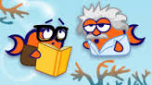
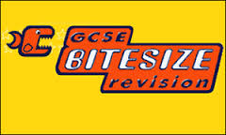
Go to www.bbc.co.uk/bitesize/ go to the GCSE Religious Studies section and make a mind-map or list of bullet points about a topic of your choice…
______________________________________________________________________________
______________________________________________________________________________
______________________________________________________________________________
______________________________________________________________________________
______________________________________________________________________________
______________________________________________________________________________
______________________________________________________________________________
______________________________________________________________________________
______________________________________________________________________________
______________________________________________________________________________
______________________________________________________________________________
______________________________________________________________________________
______________________________________________________________________________
______________________________________________________________________________
______________________________________________________________________________
______________________________________________________________________________
______________________________________________________________________________
______________________________________________________________________________
______________________________________________________________________________
______________________________________________________________________________
______________________________________________________________________________
______________________________________________________________________________
______________________________________________________________________________

Google “philosophical quotes” or “philosophy quotations”.
Choose the five quotations you like the most, explain what some of the quotes mean and why they are true on the next page…

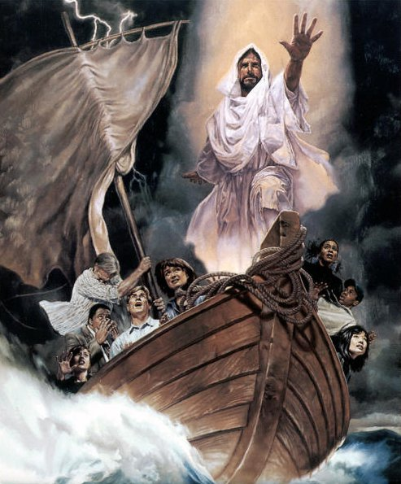
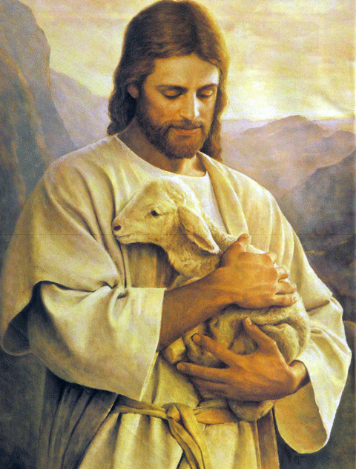
What ideas might the artist be trying to show with these pictures?
CREATE A MIND-MAP OF IDEAS

Debate!
“This house believes that there is an afterlife.”
FOR
AGAINST
ARGUMENTS

Feminism: Colour-code match the quotes
to the philosopher!
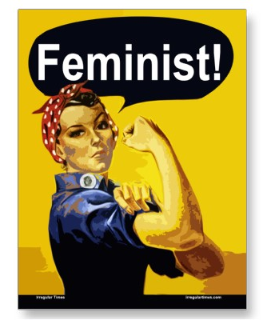
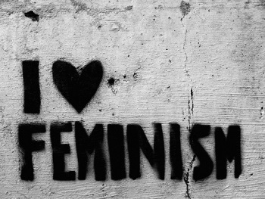
Gloria Steinem
Mother Jones
Cheris Kramarae
Simone de Beauvoir
Dolly Parton
Timothy Leary
George Carlin
Elizabeth Cady Stanton
“Women who seek to be equal with men lack ambition”
“A feminist is anyone who recognizes the equality and full humanity of women and men.”
“Woman's degradation is in man’s idea of his sexual rights. Our religion, laws, customs, are all founded on the belief that woman was made for man.”
“Feminism is the radical notion that women are human beings.”
“I'm not going to limit myself just because people won't accept the fact that I can do something else.”
“Men are from Earth, women are from Earth. Deal with it.“
“I'm not a humanitarian, I'm a hell-raiser. “
“A woman without a man is like a fish without a bicycle.”
“One is not born, but rather becomes, a woman.”
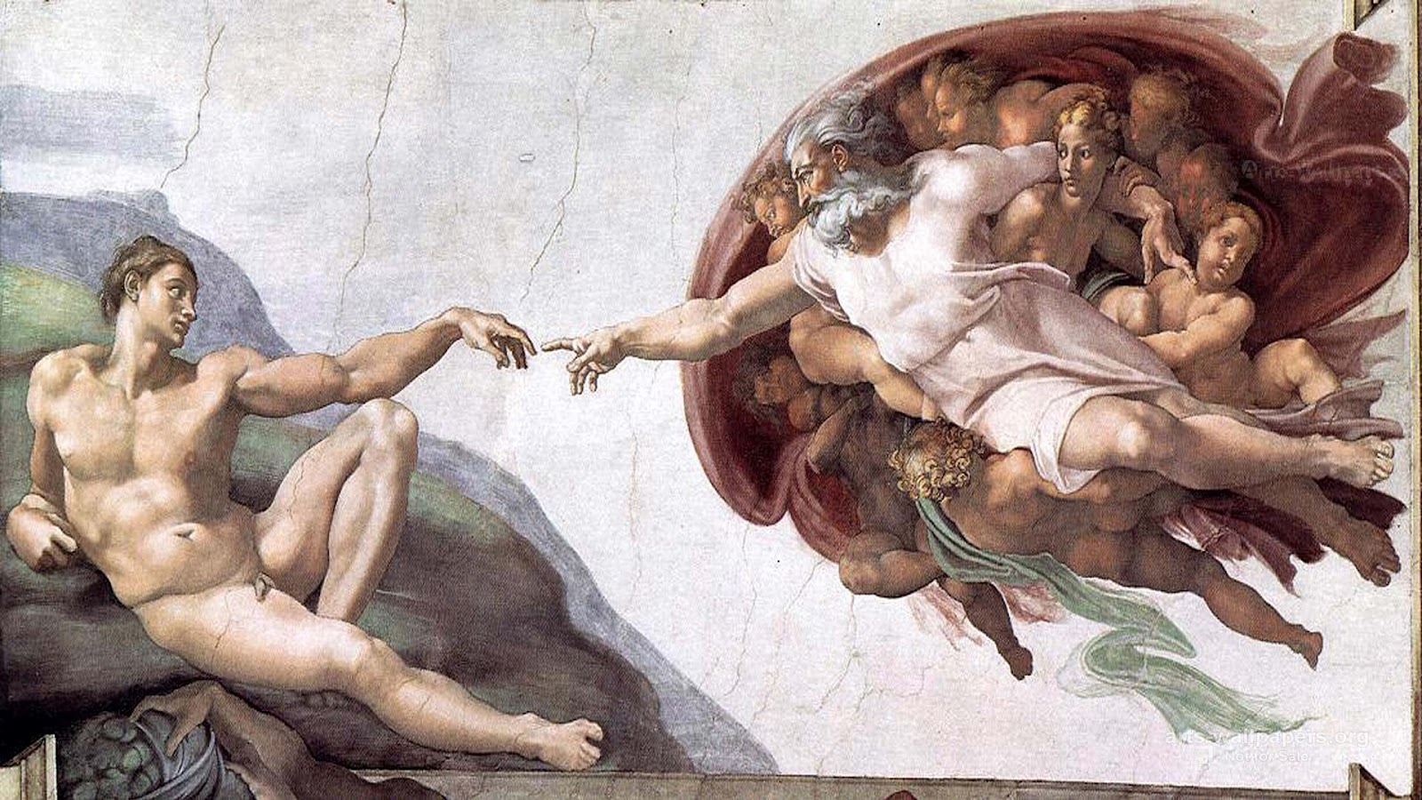
What ideas might the artist be trying to show with this picture?
CREATE A MIND-MAP OF IDEAS
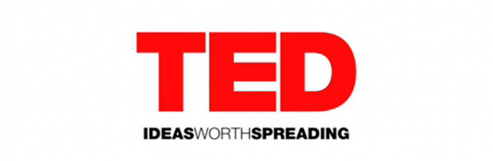
TED.COM/TALKS
Over 1000 talks by The World’s greatest minds on their subjects of expertise!
Choose ANY talk and summarise what you learn from it you below…
______________________________________________________________________________
______________________________________________________________________________
______________________________________________________________________________
______________________________________________________________________________
______________________________________________________________________________
______________________________________________________________________________
______________________________________________________________________________
______________________________________________________________________________
______________________________________________________________________________
______________________________________________________________________________
______________________________________________________________________________
______________________________________________________________________________
______________________________________________________________________________
______________________________________________________________________________
______________________________________________________________________________
______________________________________________________________________________
______________________________________________________________________________
______________________________________________________________________________
______________________________________________________________________________
______________________________________________________________________________
______________________________________________________________________________
______________________________________________________________________________
______________________________________________________________________________

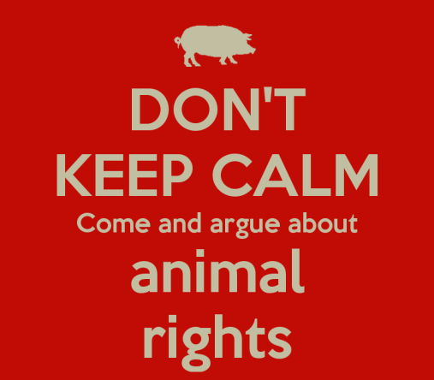
Humans Similarities Animals
Use the Venn diagram to show the differences and similarities between humans and animals.
Do you think animals ought to have rights?
How should we treat animals?
------------------------------------------------------------------
Investigating religions: Christianity
Other Interesting facts you found out…
Make a mind-map showing the beliefs held by people of this religion…
Draw the symbol of this religion below…
Where and how did it start? Who started it? Who founded the religion? Who are its main teachers?
What ideas might the artist be trying to show with this picture?
CREATE A MIND-MAP OF IDEAS
Investigating religions: Hinduism
Investigating religions: Sikhism
Where and how did it start? Who started it? Who founded the religion? Who are its main teachers?
Draw the symbol of this religion below…
Make a mind-map showing the beliefs held by people of this religion…
Other Interesting facts you found out…
Where and how did it start? Who started it? Who founded the religion? Who are its main teachers?
Draw the symbol of this religion below…
Make a mind-map showing the beliefs held by people of this religion…
Other Interesting facts you found out…
______________________________________________________________________________
______________________________________________________________________________
______________________________________________________________________________
______________________________________________________________________________
______________________________________________________________________________
______________________________________________________________________________
______________________________________________________________________________
______________________________________________________________________________
______________________________________________________________________________
______________________________________________________________________________
______________________________________________________________________________
______________________________________________________________________________
______________________________________________________________________________
______________________________________________________________________________
______________________________________________________________________________
______________________________________________________________________________
______________________________________________________________________________
______________________________________________________________________________
______________________________________________________________________________
______________________________________________________________________________
______________________________________________________________________________
______________________________________________________________________________
______________________________________________________________________________

Go to www.bbc.co.uk/bitesize/ go to the GCSE Religious Studies section and make a mind-map or list of bullet points about a topic of your choice…
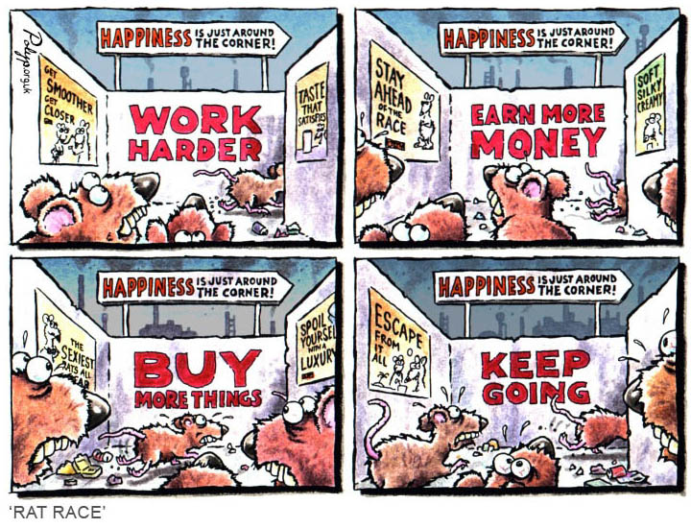
What ideas might the artist be trying to show with this cartoon?
CREATE A MIND-MAP OF IDEAS
“This house believes that animals have rights.”
Debate!
ARGUMENTS
AGAINST
FOR
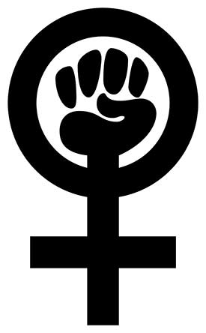
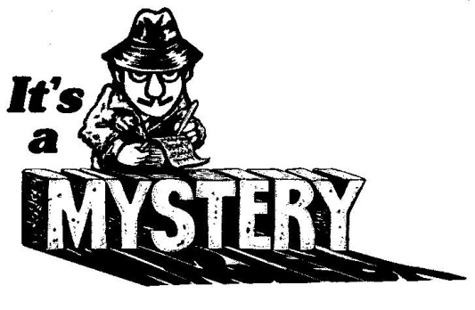
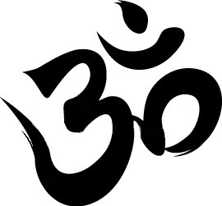
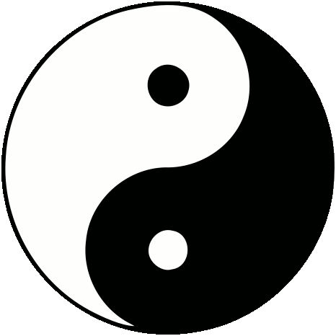
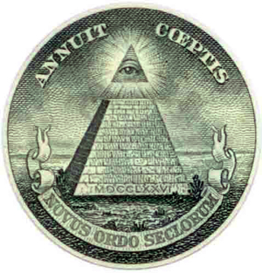
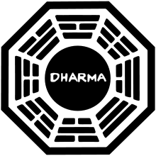
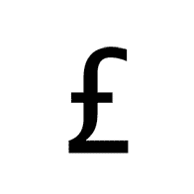
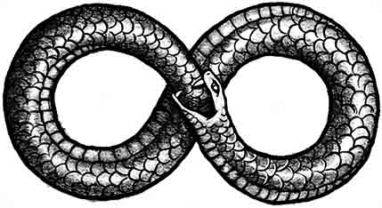
What do the following symbols mean?
Label the ones you can identify…
Debate!
“This house believes that miracles happen.”
FOR
AGAINST
ARGUMENTS
Investigating religions: Islam
Other Interesting facts you found out…
Make a mind-map showing the beliefs held by people of this religion…
Draw the symbol of this religion below…
Where and how did it start? Who started it? Who founded the religion? Who are its main teachers?

filmsforaction.org/walloffilms/
Choose any documentary from the above site (with parental guidance) Summarise what you have learnt from it below…
______________________________________________________________________________
______________________________________________________________________________
______________________________________________________________________________
______________________________________________________________________________
______________________________________________________________________________
______________________________________________________________________________
______________________________________________________________________________
______________________________________________________________________________
______________________________________________________________________________
______________________________________________________________________________
______________________________________________________________________________
______________________________________________________________________________
______________________________________________________________________________
______________________________________________________________________________
______________________________________________________________________________
______________________________________________________________________________
______________________________________________________________________________
______________________________________________________________________________
______________________________________________________________________________
______________________________________________________________________________
______________________________________________________________________________
______________________________________________________________________________
______________________________________________________________________________

THE TED TALK CHALLENGE!
TED.COM/TALKS
Over 1000 talks by The World’s greatest minds on their subjects of expertise! Can you beat ‘The Ted Talk Challenge?
Congratulations
on beating
The TED Talk Challenge!
MY TOP TEN TED TALKS!
1. ____________________
_____________________
2.____________________
_____________________
3.____________________
_____________________
4.____________________
_____________________
5.____________________
_____________________
6.____________________
_____________________
Number Watched
1
5
10
20
40
60
80
100

Religious Education Suggested Reading List
· I am Malala
· Time Riders
Asha and the Spirit Bird
· Harry Potter series
· Noughts and Crosses
· The Lion, The Witch and The Wardrobe
Children’s book of Philosophy
RE at the Movies
Many films include topics we discuss in RE. If you watch any of these films think about how they relate to the topics, make a few notes to remember this.
U
· Comparison of traditional Disney vs modern – e.g Snow White and Frozen – Gender roles
· The Miracle Maker* - The Life of Jesus
· The Prince of Egypt* - The Life of Moses
· The Hunchback of Notre Dame - Prejudice
PG – Please check you have permission before you watch any of these.
· Life of Pi - Journey of internal discovery
· He Named me Malala* - Equality, Forgiveness, Human Rights
· Evan Almighty* - Noah’s Ark
· The Chronicles of Narnia* - Christian symbolism
· A Walk to Remember - Atonement
· Harry Potter and the Chamber of Secrets - Prejudice

