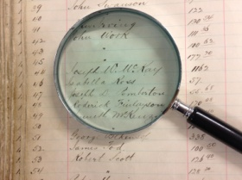
Year 11 / 12 History Assignment
Independent research project

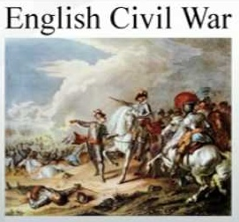
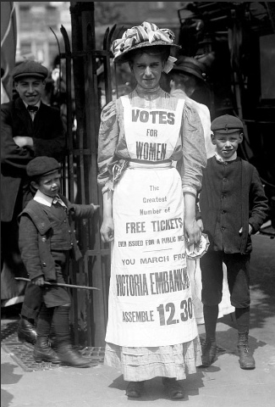
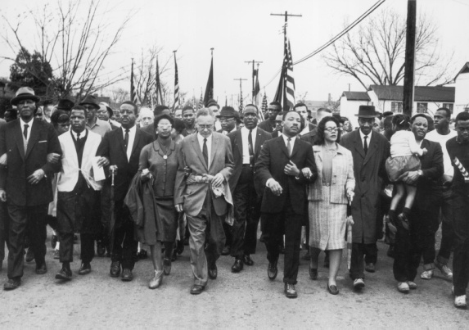
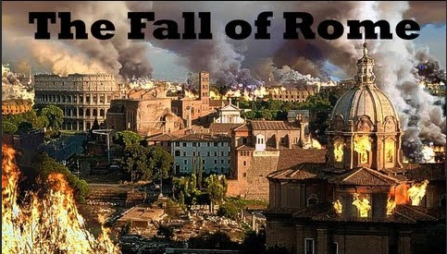
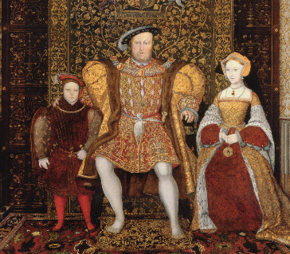
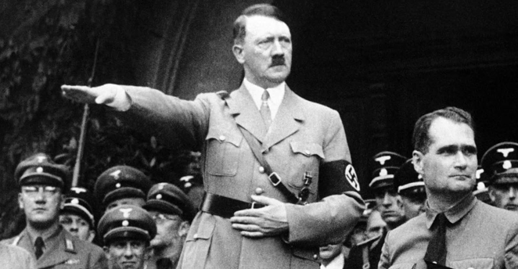
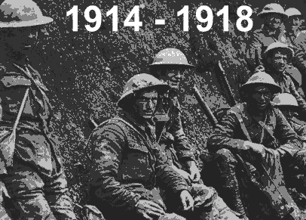
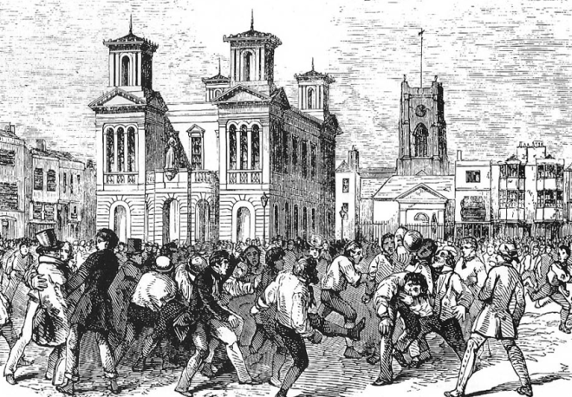

Is History right for you?

To allow you (and the History department) to decide if History is the right choice for you we would like you to complete an assessment that will give you an idea of what you can expect at A level History.
Which aspects of History are you most interested in?
Your task:
You will need to plan, resource and write an essay on causation from any period of History you would like.
To do this you need to
- Choose a time period and topic that you are interested in.
- Search for resources – use the internet (examples of websites you can use are below but specific topics will have different websites. Start with Wikipedia for general information and use the reading list at the bottom to find other websites. You can also watch documentaries e.g. on Netflix, YouTube.
- Use the resources to identify different arguments and counter-arguments - e.g. Why was the Football Association set up in 1863, what was the main cause of the WWI, what led to the Civil Rights Act in 1964?
- Find at least 2 contemporary sources – what can these sources tell your about your enquiry?
- Include your judgement.
Possible topics may include
- Civil Rights in USA
- Causes of the English Civil War
- An aspect of medicine
- Changing role of women
- The origins and impact of the organised sport in England

How you will be assessed.
Skill attribute being tested | How assessed | Met yes / no – comment
Love of history | Ability to find at least one topic that interests you.
Independent research | Successfully searched and found useful books, articles etc. with some teacher guidance if needed
Time management | Meeting deadlines
Organisation of work | Well-structured written essay
Identifying debate in History | Summary of arguments and counter argument – in the plan and the written work
Use of contemporary sources | Source evaluation in written work
What your work should look like. (see planning sheet below)
You will need to write a short essay about your chosen topic to explain the cause / effect or significance of events similar to the 16 mark question in paper 1 and 2.
For example a plan for the Civil Rights question may look like this.
Topic - Causes of Civil Rights for Black Americans 1863-1964.
Introduction - what civil rights did Black Americans have at the start and end of the time period? What are the main reasons for this?
Paragraph 1 - main argument for gaining rights - individuals. In this paragraph you would discuss the work of Martin Luther King, Rosa Parks etc
Paragraph 2 - an alternative view - e.g. the government. Discuss what the government did to increase (or not) civil rights.
Paragraph 3 - a third view e.g. The Supreme Court. Discuss the impact of key decision e.g. Brown Vs Board of Education.
Paragraph 4 - your sources. What sources from the period did you find. What did they tell you? You only need to pick two to write about. E.g. MLK's 'I have a dream' speech.
Conclusion - the main cause, impact or significance of your topic

Remember to include a reading list of all websites, articles, documentaries, TV programmes or films relevant to your topic that you watched.
Possible Websites you could use-
www.google.com (good place to start)
wikipedia.org
http://www.bbc.co.uk/history/british/
https://www.history.co.uk/
https://www.massolit.io/ - Username email address: jcs009@jcsonlineresources.org Password: JCSFoundation
https://www.senecalearning.com/
https://www.iwm.org.uk/ - Imperial War Museum
https://www.nationalarchives.gov.uk/
https://archiveshub.jisc.ac.uk/
https://www.britishpathe.com/
https://www.youtube.com/

Before you start think about a topic you may be interested in and you are able to access resources for. Research this topic using some of the websites above and any TV programmes that may be relevant.
During your research identify key debates amongst historians and complete the planning sheet before you start any writing.
If you would like help please email Miss McCabe lmccabe@prospect.reading.sch.uk. Please send your planning sheet to Miss McCabe before you start wiring.

Planning sheet
Topic you would like to study;

Date range -

Reasons for studying this topic;

Possible Question –

Main argument

Second argument

Third argument

Primary sources found
1

2

