The Forestry Step test is used to measure aerobic endurance.

How do you complete the test and what equipment do you needs?

The Multi-stage fitness test is used to measure aerobic endurance.

How do you complete the test and what equipment do you needs?

Research and ***explain*** the training methods used to improve aerobic endurance. Give an ***example*** of what a training session for each method would look like.

**Continuous training Interval training Fartlek training**

AEROBIC ENDURANCE

***Identify*** 2 sports that require Aerobic endurance and ***explain*** how they use aerobic endurance to be successful.

What is the definition of Aerobic endurance?

The Sit and reach test is used to measure Flexibility.

How do you complete the test and what equipment do you needs?

Research and ***explain*** the training methods used to improve Flexibility. Give an ***example*** of what a training session for each method would look like.

**Static stretch training Ballistic stretch training Proprioceptive neuromuscular stretch training**

FLEXIBILITY

***Identify*** 2 sports that require flexibility and ***explain*** how they use flexibility to be successful.

What is the definition of Flexibility?

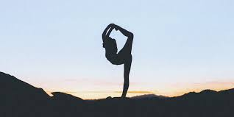

The one minute press-up test is used to measure Muscular endurance.

How do you complete the test and what equipment do you needs?

Research and ***explain*** the training methods used to improve Muscular endurance. Give an ***example*** of what a training session for each method would look like.

**Circuit training Free weight training Plyometric training**

MUSCULAR ENDURANCE

***Identify*** 2 sports that require Muscular Endurance and ***explain*** how they use Muscular Endurance to be successful.

What is the definition of Muscular Endurance?

The one minute sit-up test is used to measure Muscular endurance.

How do you complete the test and what equipment do you needs?

The grip dynamometer test is used to measure Muscular endurance.

How do you complete the test and what equipment do you needs?

Research and ***explain*** the training methods used to improve Muscular Strength. Give an ***example*** of what a training session for each method would look like.

**Circuit training Free weight training Plyometric training**

MUSCULAR STRENGTH

***Identify*** 2 sports that require Muscular Strength and ***explain*** how they use Muscular Strength to be successful.

What is the definition of Muscular Strength?

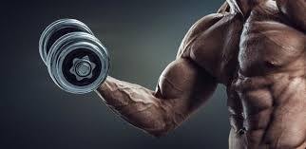

The 35m sprint test is used to measure Speed.

How do you complete the test and what equipment do you needs?

Research and ***explain*** the training methods used to improve Speed. Give an ***example*** of what a training session for each method would look like.

**Interval training Hollow sprint training Acceleration sprint training**

SPEED

***Identify*** 2 sports that require Speed and ***explain*** how they use Speed to be successful.

What is the definition of Speed?

