Dear Parent/Carer
Up to one in three people who have COVID-19 can spread the virus without knowing. This is because they have no symptoms. To reduce the spread of the virus, we need to identify those individuals. We can do this in Prospect by carrying out tests at home twice every week, 3-4 days apart.
The Government has recently announced that all secondary and college aged students will be offered tests to make the return to Prospect safer for everyone.

Testing students at home
Students will collect home test kits from their tutor on the following dates this week - 17th Year’s 13, 12 & 11. 18th Years 10 & 9 and 19th Years 7 & 8.
We would like them to take their tests before school on Mondays and Fridays.
You will also need to tell the us the result of each test by sending an email to covid@prospect.reading.sch.uk
Tests are free of charge. Students will receive a pack of 3 tests in a box with a leaflet on how to take the test and report the results.
Make sure you have enough time to do the test before coming to school. Preferably this would be in the morning before school. However, we understand that for some people this may be challenging. Therefore, tests can be taken the evening before if needed. You need to report test results.

Taking the test
Students should take the test, before coming into Prospect, twice a week. We will give students a leaflet with instructions on how to do the test with the kit. There is also a useful video to show you how to take the test here.
Help and support is available, including instructions in different languages on how to test and report the results and a video showing you how to take the test.

There is no need to keep used test equipment after the test result has been reported. You can put it in your normal bin (household waste).
This does not replace symptomatic testing. If you have symptoms, you should self- isolate immediately, book a PCR test and follow national guidelines.

What should you do after the test?
If anyone tests positive you, your household, any support bubbles you are part of should self-isolate immediately in line with NHS Test and Trace guidance for 10 days.

You need to report your result to both NHS Test and Trace and to us.

You should order a confirmatory PCR test if you are testing at home (confirmatory PCR tests are not needed if the test was conducted at the Asymptomatic Test Site at School/college).

If the result of the test is unclear (void) you should do another test.

Negative and void results should be reported to both NHS Test & Trace and us.

A negative result does not guarantee that you are not carrying the virus. So, you should continue to follow social distancing, and other measures to reduce transmission such as wearing a face mask and regularly washing your hands and observing social distancing.

If you or anyone in your household gets symptoms of the virus you should follow national guidelines on self-isolation and testing.

You need to report each test result

The result of each test needs to be reported using the NHS Test & Trace self-report website: https://www.gov.uk/report-covid19-result.

You will also need to tell the school the result of each test via an email to covid@prospect.reading.sch.uk.

Why take part
Taking part in testing is voluntary and all students will be able to attend whether they take part in testing or not.
I am strongly encouraging all students to take part. Testing at home will allow your child and other students to attend Prospect as safely as possible.

Please contact Mrs J Clyne (jclyne@prospect.reading.sch.uk), our COVID Coordinator, if you have any questions or concerns about home testing.
Thank you for your support.

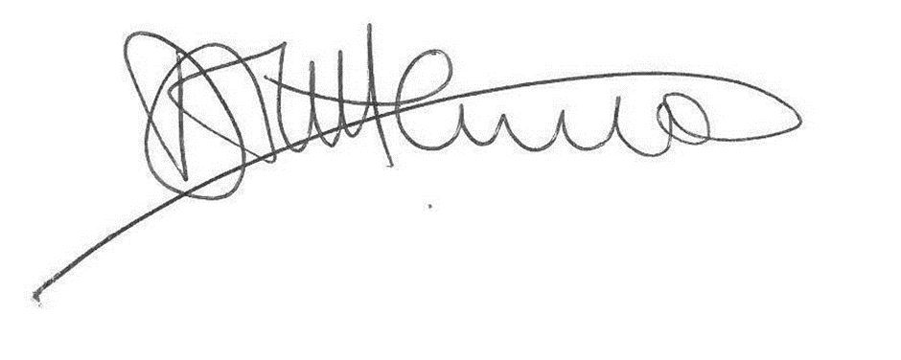
Mr D Littlemore
Headteacher

Some frequently asked questions

Do I need to give consent?
Students and parents do not give written consent to take part in the home testing programme. Please read the information below on how personal information and test results are shared and the privacy notice enclosed.
Once you open the kit you should take and report the results of the tests to NHS Test & Trace and Prospect, regardless of the result (positive, negative, or void).

Can my child take the test themselves?

Students aged 18 and over should do the test themselves and report the result, with help if they need it.

Students aged 12 – 17 should do the test themselves with adult supervisions. The adult may help the student to take the test if they need support.

Students aged 11 must be tested by an adult and the adult must report the result.

Reporting problems or issues with testing
If there is an issue with the test kit, for example something is missing, please report it by calling 119 and please also tell the school.
If an accident or injury happens whilst using the test kit, please seek medical care by calling 111 (or 999 if it is an emergency). Please also report what happened using this website: https://coronavirus-yellowcard.mhra.gov.uk/

What type of tests will be used?
We will be sending home Lateral Flow Device (LFD) tests. They are a fast and simple way to test people who do not have symptoms of COVID-19, but who may still be spreading the virus.
The tests are easy to use and give results in 30 minutes.
Further information: https://www.gov.uk/guidance/understanding-lateral-flow-antigen-testing-for-people-without-symptoms

Are LFD tests accurate?
Lateral Flow Devices identify people who are likely to be infectious. These
individuals tend to spread the virus to many people and so identifying them through this test is important.

These tests have been widely and successfully used to detect COVID-19 in asymptomatic individuals and are approved by the Medicines and Healthcare products Regulatory Agency (MHRA). The speed and convenience of the tests supports the detection of the virus in asymptomatic individuals, who would not otherwise have got tested.

The tests are highly specific, with low chance of false positives. They are also very sensitive and are able to identify the majority of the most infectious yet asymptomatic individuals. Extensive evaluation has been carried out on the tests and it shows that they are both accurate and sensitive enough to be used in the community for screening and surveillance purposes.

It is important to remember that these tests are only an aid to help stop the spread of the virus and you should continue to follow other guidance such as on wearing face coverings and social distancing.

How are LFD tests different to PCR tests?
There are 2 main types of test to check if you have coronavirus:
- polymerase chain reaction (PCR) tests check for the genetic material (RNA) of the virus in the sample - you send the sample for processing at a lab
- lateral flow device (LFD) tests detect proteins called ‘antigens’ produced by the virus
LFD tests give rapid results, in 30 minutes after taking the test.

What does it mean if my child has a positive result?
If your child has a positive antigen LFD test result they, their household and any support bubbles they are part of should self-isolate immediately in line with NHS Test and Trace guidance for 10 days. You need to report your result to both NHS Test & Trace and the school.

You should order a confirmatory PCR test if you are testing at home (confirmatory PCR tests are not needed if the test was conducted at the Asymptomatic Test Site at school).
You can book a test here.

What does it mean if my child has a negative result?
A negative result does not guarantee that your child is not carrying the virus. So, you should continue to follow social distancing, and other measures to reduce transmission such as wearing a face mask and regularly washing your hands.

What if my child has a void result?
If the result of the test is unclear (void), they should take another one. If the next test is also void, your child should take a PCR test. You can book a test here.

All test results need to be reported to both NHS Test & Trace and the school.

Do I need to send the test to a lab?
No. The LFDs supplied do not need to be sent to a laboratory to get a result and can give a quick result in around 30 minutes. Guidance on self-testing is contained in the ‘Instructions for Use’ leaflet, which comes with the test kit. There is also a useful video to show you how to take the test here.

How do you report the result?
it is positive, negative or void) using this service. You also need to tell the school the test result. You will receive a text or email from NHS Test & Trace confirming that you have reported your test result.
All test results need to be reported to both NHS Test & Trace and the school.

Can I or someone else in my household use a test kit sent home from school?
No, however whole families and households with primary school, secondary school, and college age children, including childcare and support bubbles, will be able to test themselves twice every week from home. This testing can be accessed through the following channels:

- get a rapid test at work, through workplace testing. Ask your employer for more information
- attend a test site to get tested where you will be able to see how to take the test or pick up tests to do at home (you can find your nearest test site via the postcode checker www.gov.uk/find-covid-19-lateral-flow-test-site or check your local council website)
- collect tests to do at home, find your nearest collection site COVID Test Finder (test-and-trace.nhs.uk)

If these options are not possible, there will be a supply of rapid tests for order online for people who need them the most. More information can be found on www.gov.uk/order-coronavirus-rapid-lateral-flow-tests

There is more information available about testing for households and bubbles of students.

How will personal information and test results be shared?
When your child takes a Lateral Flow test, you need to report the result. This is so that their test result can be traced, which means that you need to share some information about your child.
You need to tell the Department for Health and Social Care (DHSC):

● your child’s name
● your child’s test result
● the reference number on the test Kit
You will also need to tell your child’s school or college their test result.
Under UK law, your child’s school or college can collect and store test result data because it is in the ‘public interest’. This means that your child’s data helps us to stop the spread of the virus, and to keep your children in school. For example, we will tell your child to self-isolate if they get a positive test result.
Schools and colleges will only share information with the Department of Health and Social Care (DHSC) if the test kits used are found to be faulty. If this happens, DHSC will use our information to contact people who used the faulty tests, so that they can be tested again. This will ensure that testing is accurate and helps keep us all safe.
When you report test results online, you are sharing information with DHSC. They may share the information with your GP, local government, NHS, and Public Health England. This is so that they can offer your family health services and guidance if your child needs to self-isolate. They might also use your child’s data anonymously (without their name or contact information) to research COVID-19, and improve our understanding of the virus.
For more information on how personal data is used for testing please see the detailed privacy notice enclosed.

