26th February 2021

NHS Test and Trace: COVID-19 testing for Staff and Students

Dear Families,

The Prime Minister announced on Monday 22 February that the Government had set out its plan for the return of all students to schools as part of the roadmap for leaving lockdown.

Government Guidance

“All schools will return to face-to-face education from Monday 8th March. All secondary school and college students will take coronavirus (COVID-19) tests as they return to the classroom from Monday 8th March. Schools and colleges will have discretion on how to phase the return of their students over the week beginning 8th March to allow them to be tested on return. After an initial programme of 3 tests in school or college students will be provided with two rapid tests to use each week at home, Secondary school and college staff will also continue to be provided with two tests to use each week at home.

Staff and students in secondary schools and colleges are advised to wear face covering ins all areas, including classrooms, where social distancing cannot be maintained as a temporary extra measure”

Plan for testing

This letter is to help give you more information about the testing programme at Prospect.

Up to one third of people who have coronavirus are asymptomatic. By testing we will help to reduce the spread in school and college settings through asymptomatic transmission. As most school staff have not yet been vaccinated I am therefore strongly encouraging those returning to school to be tested, although testing is not mandatory.

Students will be invited into school for their first lateral flow test. There is no need for students to wear uniform for this test; they should return home immediately after the test has been taken. A long as they have not been informed that their test is positive, they will be able to return to face-to-face learning at school (in full school uniform) the following day.

The second and third tests will be carried out in the following ten days, during the normal school day.

Students should arrive at the Honey End Lane entrance where they will be asked to line up in their tutor group in the car park. They will be escorted into the hall to carry out their test. As soon as the test has been completed, they should return home via Honey End Lane. Parents will be notified of the result via email and/or their mobile phone via NHS Test and Trace.

Please do not send your child in at any other time; we will not be able to change the time of their test.

Years 7 and 8
Testing will take place on Wednesday 10th March, with a return to face-to-face learning on Thursday 11th March

7NA/7NB 8.30am 8NA/8NB 11.45am
7EA/7EB 9.15am 8EA/8EB 12.30pm
7SA/7SB 10.00am 8SA/8SB 1.15pm
7WA/7WB 10.45am 8WA/8WB 2.00pm

Years 9 and 10
Testing will take place on Tuesday 9th March, with a return to face-to-face learning on Wednesday 10th March

9NA/9NB 8.30am 10NA/10NB 11.45am
9EA/9EB 9.15am 10EA/10EB 12.15pm
9SA/9SB 10.00am 10SA/10SB 12.45pm
9WA/9WB 10.45am 10WA/10WB 1.15pm

Years 11.12 and 13
Testing will take place on Monday 8th March, with a return to face-to-face learning on Tuesday 9th March

11M1/11M2 8.30am 6NA/6NB 11.00am
11M3/11E1 9.00am 6EA/6EB 11.30pm
11E2/11E3 9.30am 6SA/6SB 12.00pm
11M4/11S2 10.00am 6WA/6WB 12.30pm

Consent for Testing
Although testing is not mandatory, it is strongly recommended as a means of keeping our school and wider community safe.

We will not be able to test students without a completed consent form, which can be completed electronically here. Alternatively, a word version is available here , which should be emailed to covid@prospect.reading.sch.uk . A limited number of printed copies will be available at school; these have to be completed by a parent/carer. We would appreciate these forms being completed by Friday 5th March.

How the tests work
Those taking the test will be supervised by trained staff. The lateral flow tests are quick and easy to undertake, using a swab of the nose and throat. Results (which take around half an hour from testing) will be shared directly with the individual participant. We will inform students of a positive test result only. Where participants are under 16, parents or legal guardians will also be informed. via a text/email notification of a positive or negative result from the online NHS system.

What if my child has had COVID-19?
If you child has tested positive for COVID-19 via a polymerase chain reaction (PCR) test in the last 90 days, they should NOT have the lateral flow test as the result will be inaccurate. We would appreciate it if you could inform us if this is the case for your child via covid@prospect.reading.sch.uk

What if my child tests positive?
If a student tests positive on a lateral flow device, they will be informed immediately by the school and will need to take a further ‘PCR test’ to confirm the result. This should be on the same day or as soon as possible afterwards. We will be able to provide these PCR test kits to perform at home, which then need to be posted in a ‘priority collection’ post box.

During the time while waiting for the PCR result (via text/email) they will need to self-isolate.

If the PCR test returns a positive result they will have to continue to self-isolate and follow the guidance from NHS Test and Trace.

What happens if the test is negative?
While a small number of students may need to repeat the test if the first test was invalid or void for some reason, students who test negative will be able to return to/stay in school and resume their activities as normal. Students will be informed of negative test results via text/email. Where participants are under 16, parents or legal guardians will also be informed.

What if staff or students have been in close contact with someone in school who tests positive?
The staff member or student will be notified that they are a close contact by the school, and will need to follow the current government guidance to isolate for 10 days.

What if my child develops symptoms?
This testing programme at school is for people with no symptoms. If your child develops symptoms at any time (including a high temperature; a new, continuous cough; or a loss or change to their sense of smell or taste) they must immediately self-isolate, and book a test by calling 119 or visiting https://www.gov.uk/get-coronavirus-test.

We will support our staff and pupils throughout, but please contact us if you have any questions. You can contact the office emailing enquiries@prospect.reading.sch.uk. A summary of this information is available on our website here.

With best wishes,
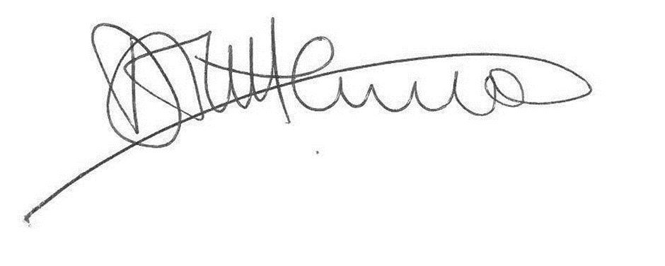
Mr D Littlemore
Headteacher

