Year 6
DRAMA AND THEATRE Transition Workbook

Acting is the art or craft of performing in media such as theatre, television, radio or film. Generally, a story is told through actions, those of the actors, who take on a role or a character in a story. Acting is globally significant as an art form in view of the role of the creative industries in today’s society and as a profession that many people seek to enter, which in turn can bring about recognition, fame and celebrity status. Welcome to Prospect School! Welcome to the world of drama!
Complete this Workbook during your summer holidays. It will help you get to know the Drama World!
Don’t forget to save your work!
Year 6 Drama
PROJECT:
Theatre through time
KEY VOCABULARY:
Here is a list of the important words that will be often used in this project. Please make sure you understand what they mean. A very good place for you to start is by looking up the meanings of these terms and making a note of them!
Research, playwright, theatrical style, context, stage configuration, audience, physical theatre, interpretation.
Skills/Knowledge/Techniques
Text Analysis
Interpreting a script for performance as an actor, director and designer
Script writing skills
Editing and formatting a script
LEARNING JOURNEY
In this project you will be introduced to drama, theatre history and the styles of performance through the ages!

Lesson 1

In this lesson you will create a timeline of the main European theatrical styles through history. We use timelines to help us create context. This means that we understand something in relation to how it fits in with the other things around it.
For this lesson you will need some string, wool, ribbon or something similar, some scissors, a printer or paper and pens, pegs or paperclips.
Task 1 (20 Minutes)
Research:
You should find out the dates of the following key historical events. For each event create a small card with the name of the event, an image and the date of the event on it.
An example has been done for you
The Great Fire of London
1666

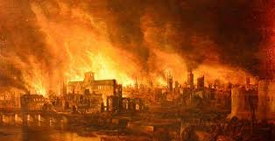

Key historical events to research:
- The first Olympics
- The Norman Conquest of Britain
- The Black Death arrives in Europe
- Queen Elizabeth 1st crowned
- The American Civil War starts
- The start of the Industrial Revolution
- Queen Victoria crowned
- World War 1 Starts
- Word War 2 starts
- The first man on the moon
- The first Glastonbury
- The first home computer
- The date Facebook was created
- 2020

Task 2 (20 Minutes)
Now create cards for different theatre styles which have the date, the style and a picture on them. An example has been done for you.
Naturalism
Late 1800s to present Day
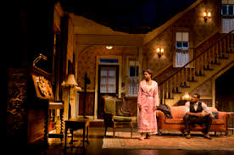

Key Theatrical Styles to research
- Greek Theatre
- Medieval Theatre
- Shakespearean (Renaissance theatre)
- Restoration Comedy
- Naturalism
- Epic Theatre
- Physical Theatre
- Interactive/Immersive theatre

Task 3 (10 minutes)
- Take a long piece of string and attach it at shoulder height across a room in your home.
- Now, using pegs or paperclips attach the historical events cards you have made along the length of the string.
- Now add your theatrical styles in the right places along the timeline.
- Take a photograph of your timeline and paste or stick it in the box below.

End of Lesson 1

Lesson 2

In this lesson you will be able to become an expert in the theatrical style of your choice.

Task 1 (30 Minutes)
Pick one of the styles of theatre from your timeline. You must pick a style that you are totally unfamiliar with.
Research and find out as much as you can about that style of theatre. Think about the audience, the stage configuration (the shape of the stage), the theatre building, the features of the style both acting and design, famous plays, famous productions, famous playwrights, how this style is different from others you have studied. Plus, anything else you think is interesting.
Make notes of all of the above.

Task 2 (30 Minutes)
Create a fact sheet to teach someone about your chosen style. You can include quotes, web links, images, diagrams, and explanations – anything you like as long as you make it interesting and accurate.
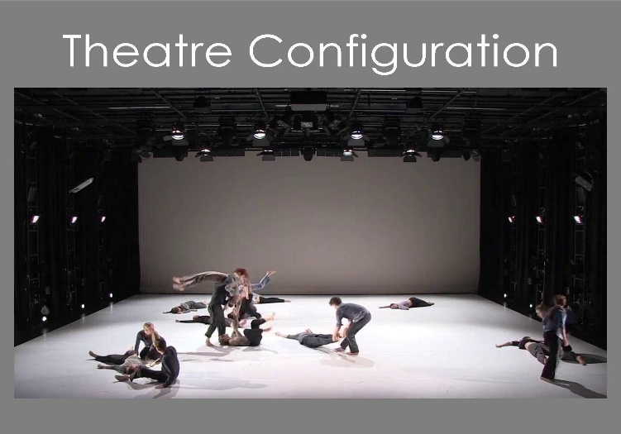

Lesson 3

In this lesson you will explore contemporary theatre. Contemporary means that it is happening now.
Frantic Assembly is a physical theatre company who devise a wide range of plays. Devising is when a theatre company creates an original piece of theatre from scratch rather than interpreting an existing play.
One of the plays created by Frantic Assembly is called “The Curious Incident of the Dog in the Night Time”.

Task 1 (30 minutes)
Watch the following clips and read the summary of the play on the next page.
https://youtu.be/RYDFdY3IZBM
https://www.franticassembly.co.uk/the-frantic-method

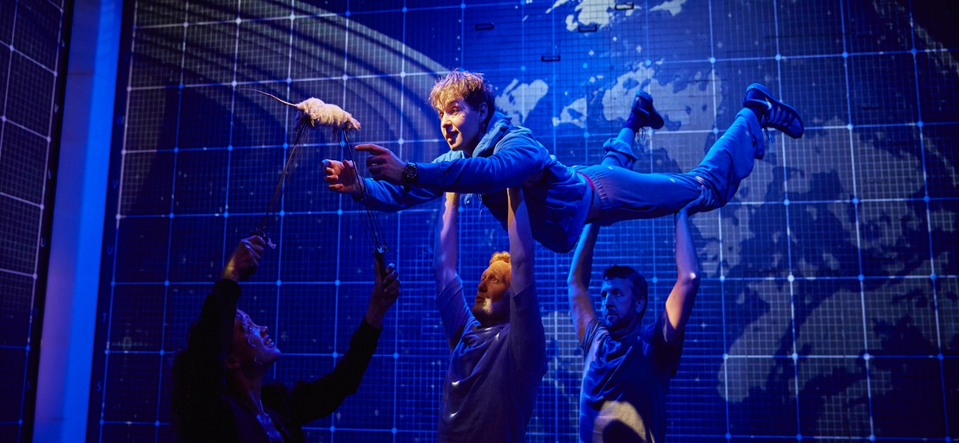

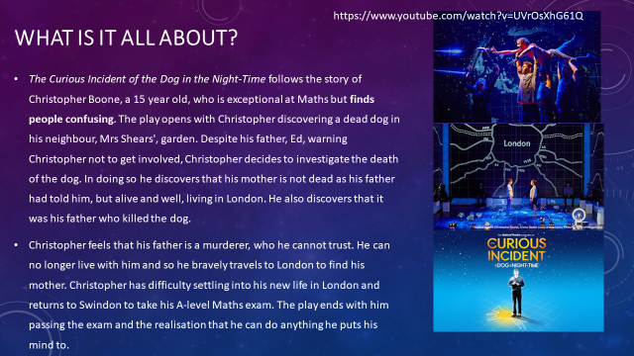

Task 2 (30 Minutes)

Based on everything you have learned, create a story board for the play “The Curious Incident of the Dog in the Night Time”. Your story board should be 6 – 9 panels long and should show the key points of the play. The first panel has been done for you as an example.
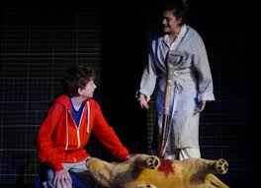

Christopher discovers a dead dog in his garden. He decides to investigate.

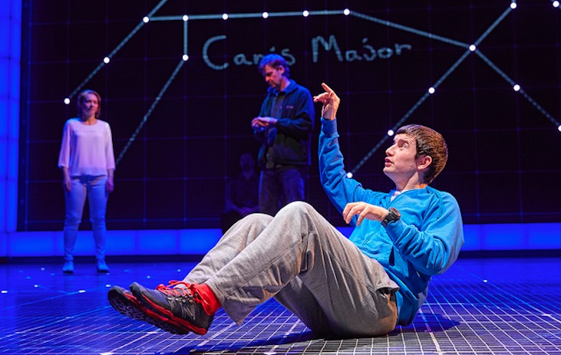

End of Lesson 3

Lesson 4 (This is part of two linked lessons)

Devising your own sequence
In this lesson you will experiment with devising a sequence of movement in the style of Frantic Assembly.
For this lesson you will need clothes, trainers or bare feet, a sturdy chair and some room to move!
Task 1 (10 minutes)
Watch the following clip twice, it will show you how to create a sequence of movement using a chair.
https://youtu.be/tEwxEwE5dgs

Now write 3 safety points that the video mentions.

What does the actor mean when she uses the word parallel?

Task 2 (20 minutes)
Using the video clip try to copy and learn the sequence of movements that the actor creates. You might have to stop and start the clip several times in order to do this.
Task 3 (20 minutes)
Choose some music that you think fits well with the movement and the pace of your devised sequence. Rehearse your sequence to the music you have chosen.
Task 4 (10 minutes)
Either
Record your sequence and watch it back looking for things that you think work or areas that you would change and improve.
Or
Show your sequence to someone at home and get them to give you feedback on what they think works and what you could change to improve your piece.

End of Lesson 4

Lesson 5 (Developing your piece)

Adding dialogue: In this lesson you will develop your physical theatre piece by adding speech to your sequence.

Task 1 (10 minutes)
Watch the following YouTube clip. This is another physical theatre company called DV8. They have created a choral piece of movement with an added monologue.
What skills and techniques do you notice being used in this clip?
https://youtu.be/PvctLx8H8xs

Task two (30 minutes)
The script below is a monologue from “The Curious Incident of the Dog in the Night Time”.
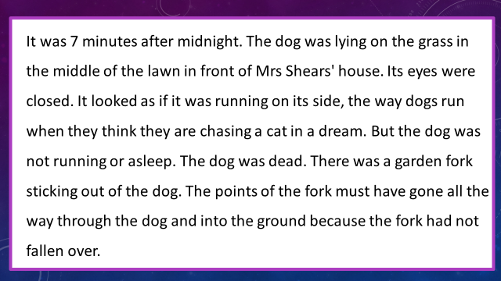

You must add this monologue to the sequence of movement that you created last lesson. If you need to go through the sequence more than once or choose a longer piece of music to perform to, that is absolutely fine. If you want to take inspiration from the DV8 clip and add in some more moves to your sequence, that will be fine too.

Task 3 (10 minutes)
Think about how you will know if your performance has been a success. Set yourself 4 assessment criteria and write them down in your books. You might like to think about how you use the space, show the character, bring the different elements or use your performance skills to achieve the effect you want.

End of lesson 5

That was the end of the activities but the beginning of your introduction to a whole new, magical world! I hope that you enjoyed yourselves and had fun.
I am looking forward to teaching you next year and taking you on a journey full of adventures and magic!
Ms Akrivopoulou-Head of Drama

