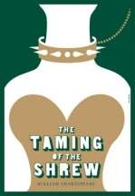
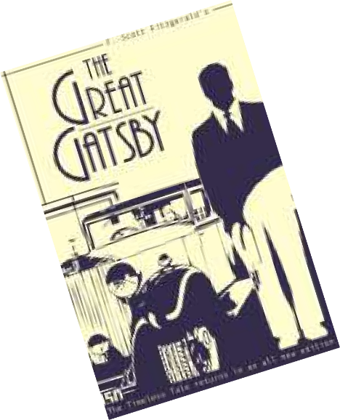
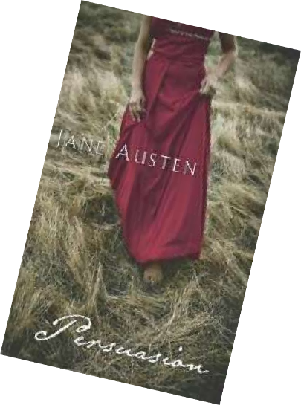
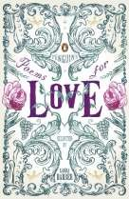

Welcome to the Sixth Form English Department!
This booklet will provide you with some ideas for your course and some preparation to do for September.
Please have a good look through it so that you know what to expect in September…

English Literature A Level

For information about the structure and content of the course, go to http://www.aqa.org.uk/subjects/english/as-and-a-level/english-literature-a-7711-7712
In these pages, you’ll find lots of suggestions about things you can read or do to prepare for your course

It is important to be sure that you will enjoy and manage the quantity and quality of reading that you will have to do during the course. There will be three ‘compulsory’ texts and a poetry anthology which we will work on in depth, but you will have to read all or part of them independently. The more widely you read, the easier you will find it to relate the set texts to Literature in general.

As well as these English-specific activities, you will also find the course easier if you have a good general knowledge, including an understanding of current affairs, geography and history.

For example, if you read The Great Gatsby, you will find it easier if you know something about the history of America in the 1920s and what the climate is like as well as having considered the experiences of being in that time.

In English at A-Level, there are no marks for speaking and listening but those students who work well in groups and contribute to discussions tend to enjoy the course most and are often the most successful.

This summer is a great time to add to your knowledge and ensure that you have lots to contribute!

Kit List

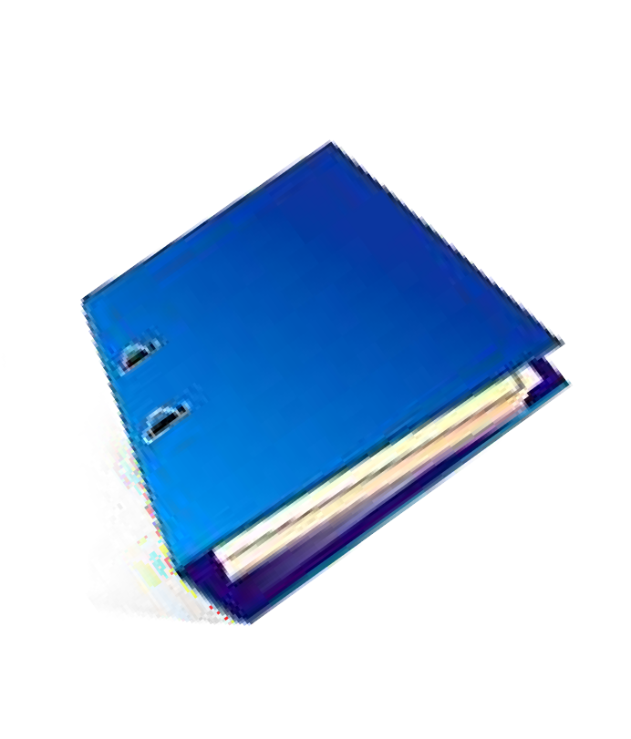
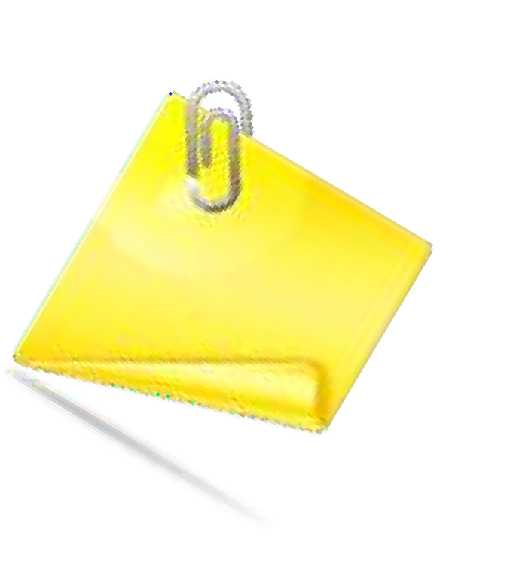
In order to be prepared for your English A level, these are some things you’ll need to have with you:
Files/folders. You’ll probably need two – one for each module. You may also want to put some dividers in each and definitely some plastic wallets to store handouts, etc.
Highlighters
Post-It Notes
Memory Stick -

We will give you an anthology but you may need to buy some texts. These will all be things you can buy in paperback and often quite cheaply from Amazon or Abebooks.

So....Why Study Literature?

To benefit from the insight of others. The body of world literature contains most available knowledge about humanity--our beliefs, our self-perception, our philosophies, our assumptions and our interactions with the world at large. Some of life's most important lessons are subtly expressed in our art. We learn these lessons only if we pause to think about what we read. Why would anyone bury important ideas? Because some ideas cannot be expressed adequately in simple language, and because the lessons we have to work for are the ones that stick with us.

To open our minds to ambiguities of meaning. While people will "say what they mean and mean what they say" in an ideal world, language in our world is, in reality, maddeningly and delightfully ambiguous. If you go through life expecting people to play by your rules, you'll only be miserable, angry and disappointed. You won't change them. Ambiguity, double entendres and nuance give our language depth and endless possibility. Learn it. Appreciate it. Revel in it.

To explore other cultures and beliefs. History, anthropology and religious studies provide a method of learning about the cultures and beliefs of others from the outside looking in. Literature, on the other hand, allows you to experience the cultures and beliefs of others first-hand, from the inside looking out. The only other way to have such a personal understanding of others' beliefs are to adopt them yourself--which most of us aren't willing to do. If you understand where other people are coming from, you are better equipped to communicate meaningfully with them--and they with you.

To appreciate why individuals are the way they are. Each person we meet represents a unique concoction of knowledge, beliefs, and experiences. In our own culture we find an infinite variety of attitudes and personalities, hatreds and bigotries, and assumptions. With each exposure to those who differ from us, we expand our minds. We may still reject their beliefs and assumptions, but we're one step closer to understanding them.

To expand our grasp of the machinations of history. History and literature are inextricably intertwined. History is not just names and dates and politics and wars and power. History is about people who were products of their time with their own intricately-woven value systems. Study of literature enhances our appreciation of history's complexity, which in turn expands our appreciation of present political complexities and better equips us to predict and prepare for the future.

To exercise our brains. Our brains need exercise just like our bodies do. Don't balk at picking up the barbell and doing a few mental curls. Great literature has hidden meanings that won't slap us in the face like children’s' books will; we'll have to dig and analyse like an adult to find the gold.

To teach us to see individual bias. In a sense, each of us is an unreliable or naive narrator, but most of us mindlessly accept the stories of certain friends or family without qualification. We should remember that they are centers of their own universes, though, just like we are. They are first-person narrators--not omniscient--just like we are. The only thing that suffers when we appreciate individual bias is our own gullibility.

To encourage us to question "accepted" knowledge. As children, most of us were taught to believe what we're told and those basic hypotheses provide our

schemas, or building blocks of knowledge. As we grow, we learn to question some ideas while rejecting the offensively alien ideas outright, often without real examination. However, human progress often results from the rejection of assumed "facts." The difficulty lies in spotting our own unexamined assumptions. The more ideas we expose yourself to, the more of our own assumptions we can root out to question and either discard or ground our lives in.

To help us see ourselves as others do. Literature is a tool of self- examination. You will see your own personality or habits or assumptions in literature. The experience may even be painful. While our ego defense systems help us avoid self-scrutiny and ignore others' observations or reactions to us, literature serves as a mirror, revealing us to ourselves in all our naked, undefended glory.

To appreciate the contributions literature has made to history. The pen is mightier than the sword, yes? When a country undergoes regime change, the new regime imprisons, exiles or executes the intelligentsia--scholars and philosophers--who are seen as the keepers of the culture, creators of ideology, and instigators of revolt. See Russian, Chinese, and German history for examples. In American history, see the copious examples of pro- and anti-slavery literature as well as Thomas Paine's and Thomas Jefferson's contributions to the American Revolution.

To see the tragedy. Lenin said "A million deaths are a statistic, but one death is a tragedy." History gives you the statistics. Literature shows you the human tragedy.

To further our mastery of language. Sticks and stones may break my bones, but words build and destroy nations. Study of literature hones our language skills and teaches us new and valuable techniques for communication. A master of language can seduce your emotions and inspire you to follow him into death--or he can crush your will with a word. Language is the single most important tool of leadership and great leaders embrace its study.

To recognize language devices and appreciate their emotional power. Like good music, poetry uses wordplay, rhythm, and sounds to lull the reader into an emotional fog, and therein deliver its message. Great leaders learn to harness these techniques of communication and persuasion. Listen closely to effective advertisements and politicians and lawyers. Listen to the pleasing rhythm and wordplay of their mantras, and watch the sheep blithely flock to them: "It does not fit--you must acquit!" "Crisp and clean and no caffeine!" Politicians use prolific parallelism: "We will not tire, we will not falter, and we will not fail."

To explore ethical complexities. Only children find ethical rules cut and dried. Literature forces readers to challenge their simplistic ethical conceptions and sometimes their outright condemnation of others' actions. For example, we believe lying is wrong. But what do we mean? Do we never lie? Have you ever met a person rude enough to follow this rule implicitly? Be advised, though: ethical exploration is a mature endeavour; it is not for the thin-skinned.

To see the admirable in everyday life. We are surrounded by unsung nobility and sacrifice. Once we learn to see it in the actions of common folk, our lives will be forever richer, as will our faith in humanity itself.

To learn better ways to behave. An untold amount of our opinions and words and reactions are absorbed during childhood and from our culture. Literature teaches us better courses of action and more effective responses to situations...if we let it.

To know we aren't alone. Others have been where we are, have felt as we feel, have believed as we believe. Paradoxically, we are unique just like everyone else. But we aren't alone. Others were here and they survived...and may have even learned from it--and so may we.

To refine our judgment. This involves several aspects of reading: exposure to new ideas and new ways of looking at old assumptions, expanded vocabulary and
understanding, and improved ability to write. Altogether, these benefits refine our ability to think, and thus guide us toward informed, mature judgment.

To learn to support our points of view and trust our own interpretations. We provide evidence for our interpretation of a story or poem when we explicate it. When
we build a solid case in support of our opinion, we build self-confidence in our own interpretations of language itself.

To develop empathy for those who are unlike us. Literature can train and exercise our ability to weep for those who are not us or ours. As children, our circles of concern stop with ourselves. As we grow, we expand those circles to our families and friends, and perhaps to our neighbourhoods, towns, cities, states or countries. Our study of literature continues to expand that realm of concern beyond the things we physically
experience.

To expand our vocabularies. New words are tools for grasping new ideas. Each new idea is a building block upon which we may acquire more knowledge. Knowledge is
power.

THE ULTIMATE ENGLISH LITERATURE QUESTIONNAIRE

Which book are you currently reading or have you just read?

Who was your favourite author when you were a child?

What was your favourite book when you were a child?

Which magazine(s) did you read as a child?

Which magazine(s) do you read now?

Which literary character would you least like to be stranded on a desert island with and why?

In which literary/fictional location would you most like to live?

Which is the best TV/film adaptation of a book you have seen?

Which person, real or fictional, living or deceased, would you most like to have a ‘one-to-one’ with?

What is your favourite book?

Who is your favourite author?

What is the most memorable line delivered in a film?

What is your favourite film?

What is your least favourite book and why?

English Literature Summer Assignment 1
Read and annotate the following poem, then answer this question:

How does Collins present books and the act of reading in the poem ‘Books’?
You should aim to include embedded, analysed quotations and use literary terminology where appropriate.

Books
From the heart of this dark, evacuated campus
I can hear the library humming in the night,
a choir of authors murmuring inside their books
along the unlit, alphabetical shelves,
Giovani Potani next to Pope, Dumas next to his son,
each one stitched into his own private coat,
together forming a low, gigantic chord of language.

I picture a figure in the act of reading,
shoes on a desk, head tilted into the wind of a book,
a man in two worlds, holding the rope of his tie
as the suicide of lovers saturates a page,
or lighting a cigarette in the middle of a theorem.
He moves from paragraph to paragraph
as if touring a house of endless, panelled rooms.

I hear the voice of my mother reading to me
from a chair facing the bed, books about horses and dogs,
and inside her voice lie other distant sounds,
the horrors of a stable ablaze in the night,
a bark that is moving towards the brink of speech.

I watch myself building bookshelves in college,
walls within walls, as rain soaks New England,
or standing in a bookstore in a trench coat.

I see all of us reading ourselves away from ourselves,
straining in circles of light to find more light
until the line of words becomes a trail of crumbs
that we follow across a page of fresh snow.

When evening is shadowing the forest
and small birds flutter down to consume the crumbs,
we have to listen hard to hear the voices
of the boy and his sister receding into the woods.

Billy Collins

English Literature Summer Assignment 2
Read one of the following and create a presentation reviewing the text
The task:
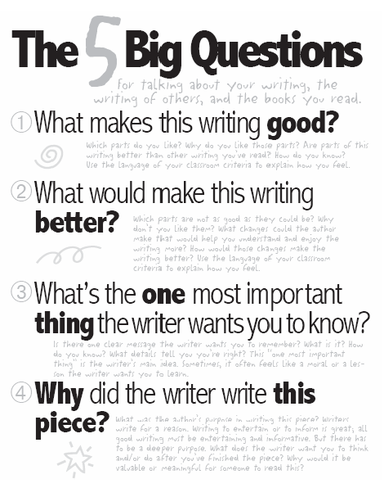
Your review must present a clear opinion and persuade the rest of the group to read your prose text. Although we don’t mind how you structure your review, you might like to include some of the following:

A clear summary of the plot (but without perhaps giving too much away)

Exploration of what influenced or inspired the author

Why you chose it and who may like it

Exploration of the author’s effective narrative choices e.g. narrative point of view, characterisation, use of time, use of setting, structure, generic conventions etc.

A reading, including close analysis, of a suitable section (approximately a page)

Achebe, Chinua | Things Fall Apart | The story of how European colonialism affects the people in a West African community.
Ali, Monica | Brick Lane | A young Bangladeshi girl comes to terms with arriving in the East End for an arranged marriage.
Atwood, Margaret | Oryx and Crake  Lady Oracle  Cat’s Eye  Heart Goes Last | Any novel or short story collection (you can't do The Handmaid's Tale) would be good.
Austen, Jane | Pride and Prejudice  Sense & Sensibility  Mansfield Park  Emma  Northanger Abbey | Brittle romantic comedies set in the early years of the 19th Century.
Boyd, William | A Good Man in Africa  Brazzaville Beach  An Ice-cream War | A post-colonial comedy about an Englishman's attempts to make sense of African society.  Powerful story of a woman coming to terms with her past.  Two brothers enlist to fight the Germans in East Africa.
Bronte, Charlotte | Jane Eyre | The classic tale of a governess and her enigmatic employer.
Bronte, Emily | Wuthering Heights | Love and passion on the Yorkshire Moors.
Carey, Peter | Jack Maggs  True History of the Kelly Gang  Oscar and Lucinda | A convict returns from Australia to early Victorian London.  The story of Australia's Robin Hood. Written in a challenging style, but a brilliant depiction of life in early Australia.  A beautiful, bizarre love story about two oddballs, set in 19th Century Australia.
Carter, Angela | The Bloody Chamber  The Magic Toyshop  Nights at the Circus | Dark and disturbing reworkings of classic fairy tales.  Bizarre story of a girl moving in with peculiar relatives.  Part woman, part swan: Sophie Fevvers is a circus artiste on a journey through turn of the century London and Russia.
Chopin, Kate | The Awakening | Set in and around New Orleans at the end of the 19th Century, the story of a young woman with unconventional views.
Coetzee, JM | Disgrace  Foe | A university professor deals with the consequences of an affair in post-Apartheid South Africa.  Robinson Crusoe's tale retold from a female perspective.
Collins, Wilkie | The Moonstone  The Woman in White | One of the earliest detective novels, the quest for a fabulous Indian treasure.  Brooding Gothic melodrama, full of mental asylums, evil villains and women wearing white.
Conrad, Joseph | Heart of Darkness | A brutal depiction of colonialism in Central Africa.
Defoe, Daniel | Robinson Crusoe | 18th Century novel about a castaway surviving on a desert island.
Forna, Amanatta | The Memory of Love | Set in Sierra Leone, a real slow burner.
Forster, E.M. | A Passage To India  Howards End  A Room With A View | A culture clash novel set in the days of the Indian Raj.  An Edwardian romance depicting a clash of cultures between two families.  A cheerful romantic comedy of young love and Italy.
Ishiguro, Kazuo | The Remains of the Day  Never Let Me Go | A haunting relationship between a repressed butler and an opinionated house keeper.  A disturbing tale of boarding school life with a horrific twist.
Kureishi, Hanif | The Buddha of Suburbia | Karim, a dreamy teenager, is desperate to escape suburban South London and experience the forbidden fruits which the 1970s seem to offer.
Lessing, Doris | The Grass is Singing | A tragic story of a crumbling marriage, set in southern Africa during the Apartheid era.
Levy, Andrea | Small Island  The Long Song | Warm romantic comedy about the trials and tribulations of the Windrush immigration.  The story of a slave in Jamaica during the years when slavery was abolished.
Mistry, Rohinton | A Fine Balance | A fairly hefty novel set in 1970s India.
Morrison, Toni | Beloved  Song of Solomon  The Bluest Eye | Brilliant but disturbing novel about a freed slave in America after the Civil War.  A fascinating depiction of the American Black community in the mid-20th Century.  Set in 1940s Ohio, a savage portrayal of a poor black family.
Naipaul, VS | In A Free State  The Bend in the River  A House for Mr Biswas | A complex novel about social and political change in Africa.  A picture of post-colonial Africa and the challenges people face in it.  Set in post-colonial Trinidad, a tragi-comedy about an endearing failure.
Ngozi Adichie, Chimamanda | Half of a Yellow Sun | Deals with the end of colonialism in Nigeria.
Perkins Gilman, Charlotte | The Yellow Wallpaper and Other Stories  Herland | Superb short stories from an early feminist American author.  Discovery of a new ‘all female’ land.
Plath, Sylvia | The Bell Jar | A semi-autobiographical account of a woman's breakdown.
Proulx, Annie | Fine Just the Way It Is  Bad Dirt  Close Range  Heartsongs | Astonishing collections of short stories set in the Mid-West of America, featuring a range of vivid and strange characters. Beautifully written.
Rhys, Jean | Wide Sargasso Sea | A strange prequel to the Jane Eyre story, set in the post-slavery era of the Caribbean.
Roy, Arundhati | The God of Small Things | A story of twins and their eccentric family in India.
Stevenson, Robert Louis | South Sea Tales | Stories that challenge the myth of British Imperialism at the end of the 19th Century.
Stockett, Kathryn | The Help | Friendships crossing boundaries of race and class in 1960s Mississippi.
Stoker, Bram | Dracula | Classic Gothic horror
Walker, Alice | The Color Purple | The harrowing tale of Celie, a poor black American girl between the wars

Additional Tasks.

Create a visual reading timeline showing your reading journey

Write a short response to the following question: Which literary character would you date and why?

Write an analysis of a poem of your choice – use appropriate terminology and submit the poem with your analysis

Create a timeline of all the different literary movements. Begin with the 14th Century and end with modern literature.

Reading the opening of Othello and film yourself performing one of Iago’s soliloquies.

Choose a modern/contemporary book and write a short piece arguing for it to be recognised as part of the literary canon

